SQL for KPI and Charts Validation

KPIs
- Total Revenue
- select sum(total_price) as Total_Revenue from pizza_sales;
Output
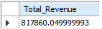
- Average Order Value
- select sum(total_price) / count(distinct order_id) as Average_Order_Value from pizza_sales;
Output
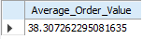
- Total Pizza Sold
- select sum(quantity) as Total_Pizza_Sold from pizza_sales;
Output
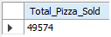
- Total Orders
- select count(distinct order_id) as Total_Orders from pizza_sales;
Output
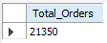
- Average Pizza Per Order
- select sum(quantity)/count(distinct order_id) as Average_Pizza_Per_Order from pizza_sales;
Output
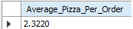

Charts
- Daily Trend for Total Orders
- select dayname(order_date) as Day_of_Week, count(distinct order_id) as Total_Orders from pizza_sales group by dayname(order_date);
Output
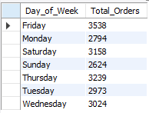
- Monthly Trend for Total Orders
- select monthname(order_date) as Name_of_Month, count(distinct order_id) as Total_Orders from pizza_sales group by monthname(order_date);
Output
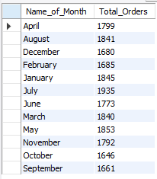
- Percentage of Sales by Pizza Category
- select distinct pizza_category, sum(total_price)/(select sum(total_price) from pizza_sales) * 100 as PS_by_PC from pizza_sales group by pizza_category;
Output
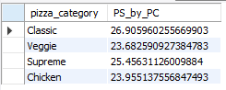

- Percentage of Sales by Pizza Size
- select distinct pizza_size, sum(total_price)/(select sum(total_price) from pizza_sales) * 100 as PS_by_PS from pizza_sales group by pizza_size;
Output
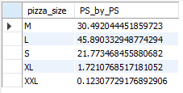
- Total Pizza Sold by Pizza Category
- select distinct pizza_category, count(quantity) as Total_Pizza_Sold from pizza_sales group by pizza_category;
Output
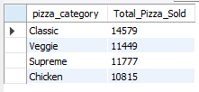
- Top 5 Best Sellers by:
- Revenue
- select pizza_name, sum(total_price) as Revenue from pizza_sales group by pizza_name order by sum(total_price) desc limit 5;
Output
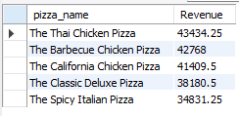
- Total Quantity
- select pizza_name, sum(quantity) as Total_Quantity from pizza_sales group by pizza_name order by sum(quantity) desc limit 5;

Output
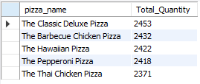
- Total Orders
- select pizza_name, count(distinct order_id) as Total_Orders from pizza_sales group by pizza_name order by count(distinct order_id) desc limit 5;
Output
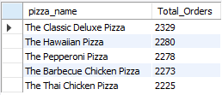
- Bottom 5 Selling Pizza by:
- Revenue
- select pizza_name, sum(total_price) as Revenue from pizza_sales group by pizza_name order by sum(total_price) desc limit 5;
Output
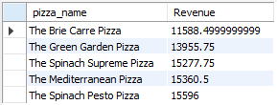
- Total Quantity
- select pizza_name, sum(quantity) as Total_Quantity from pizza_sales group by pizza_name order by sum(quantity) desc limit 5;
Output
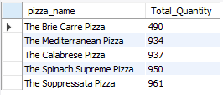

- Total Orders
- select pizza_name, count(distinct order_id) as Total_Orders from pizza_sales group by pizza_name order by count(distinct order_id) asc limit 5;
Output
